**Project Workflow: Steps to Implement ETL Process**

1. **Load Source Data**
   * Import the CSV files as source definitions into Informatica.
   * Ensure the source definitions are correctly configured to reflect the structure of the input files.
2. **Stage the Data**
   * Load the data from the source files into staging tables in the MSSQL database.
   * Create staging tables in the database, mirroring the structure of the source files, including primary and foreign key constraints for data integrity.
3. **Design Dimensional Target Tables**
   * Define and create dimensional target tables in the SQL database.
   * Ensure the dimensional tables align with the required schema for analytical purposes, including necessary primary and foreign key relationships.
4. **Map and Develop Workflows**
   * Create workflows in Informatica for each staging source table to populate the corresponding dimensional tables.
   * Implement the required transformation logic in mappings, such as:
     + **Slowly Changing Dimensions (SCD) Type 1:** Overwrite updates.
     + **SCD Type 2:** Maintain historical data.
     + **Insert-Only Logic:** For simple data addition.
5. **Integrate with the Fact Table**
   * Develop a final mapping to populate the **FACT_SALES** table.
   * Use lookups on all dimensional tables to ensure accurate integration of data into the fact table.

**Output Screenshots**

**Loading the CSV files into the staging area**

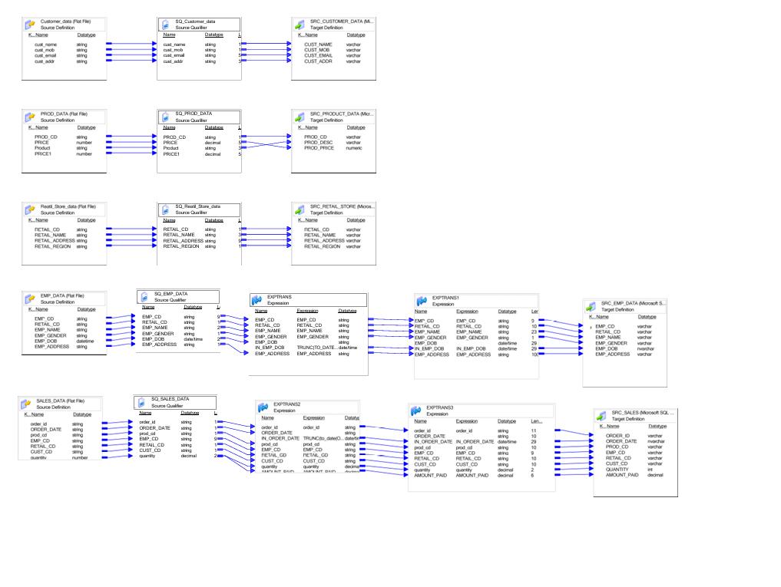 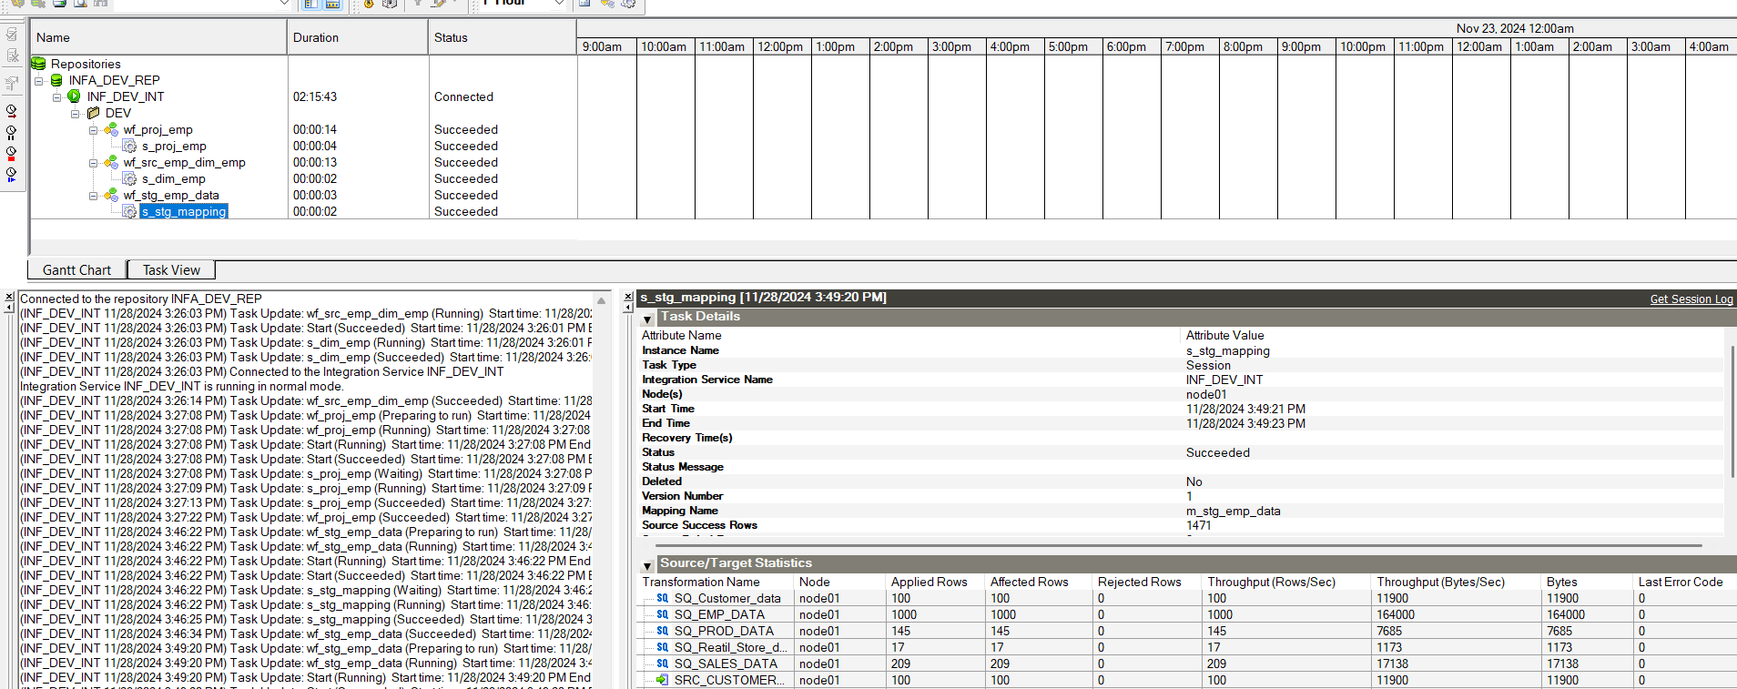

**Emp Dimension:**

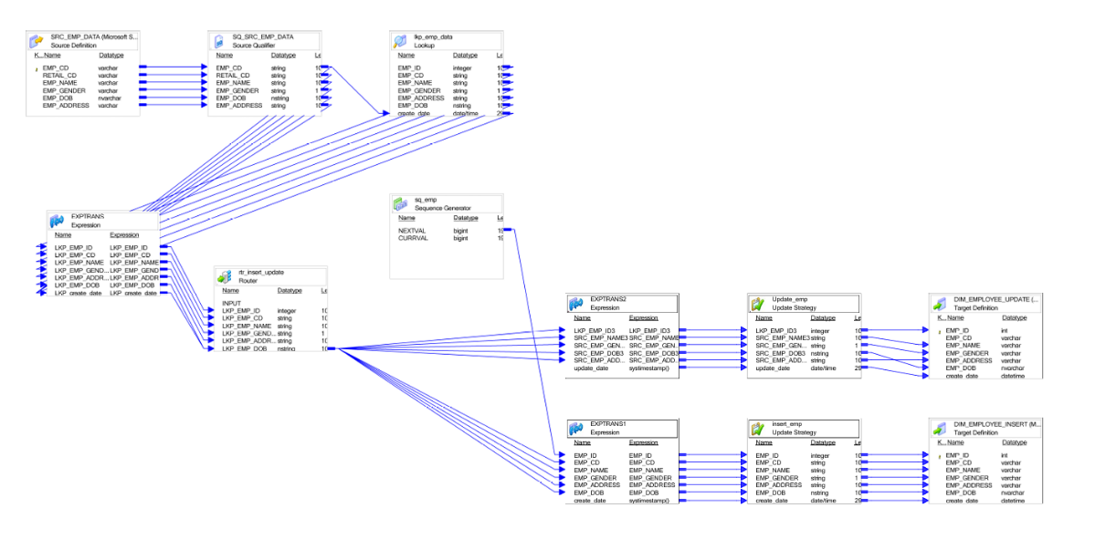

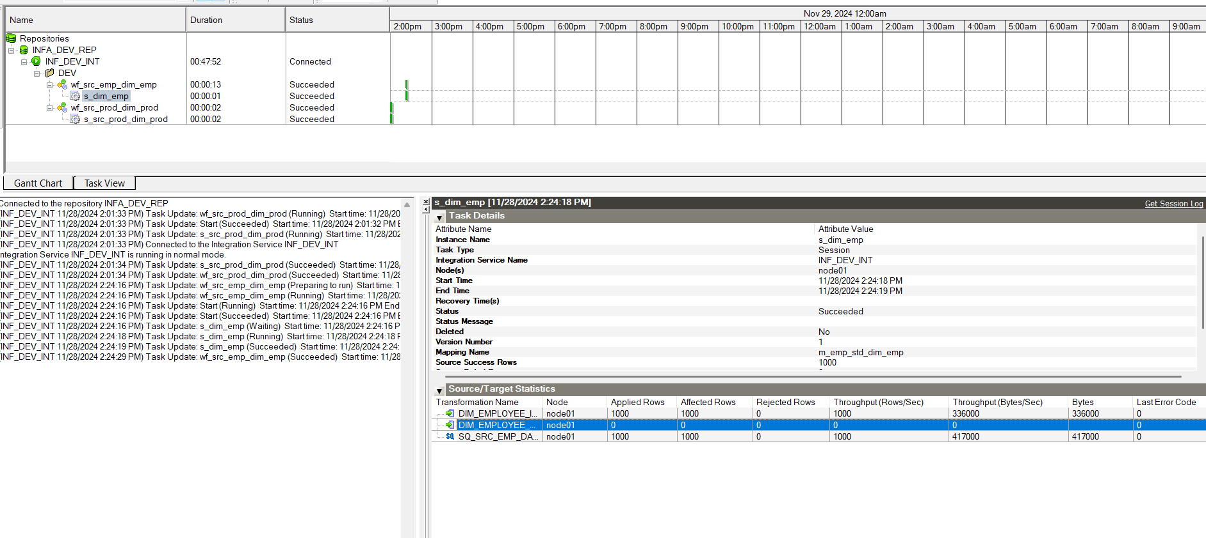

**Customer Dimension:**

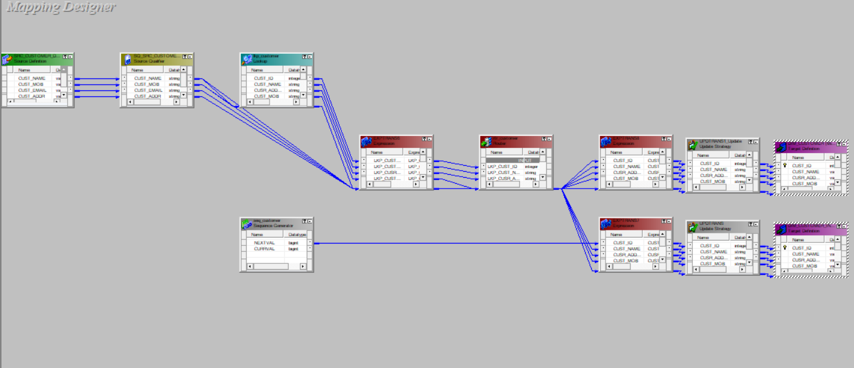

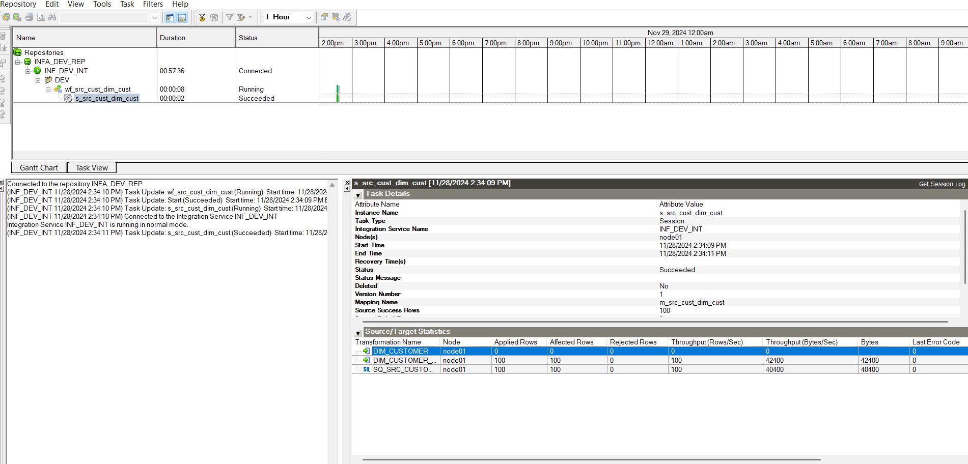

**Date Dimension**

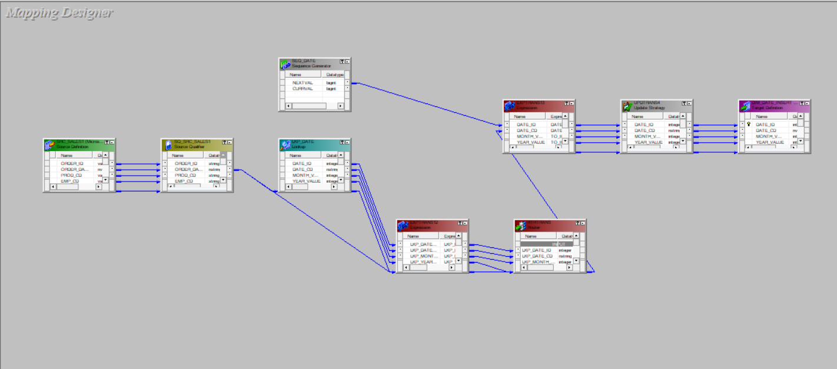

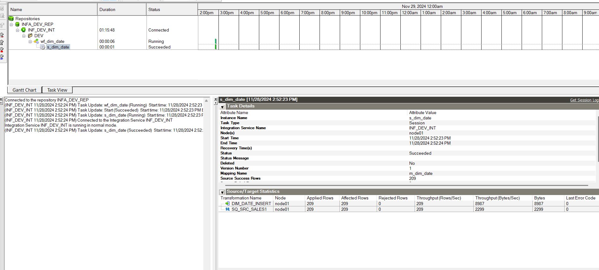

**Order Dimension**

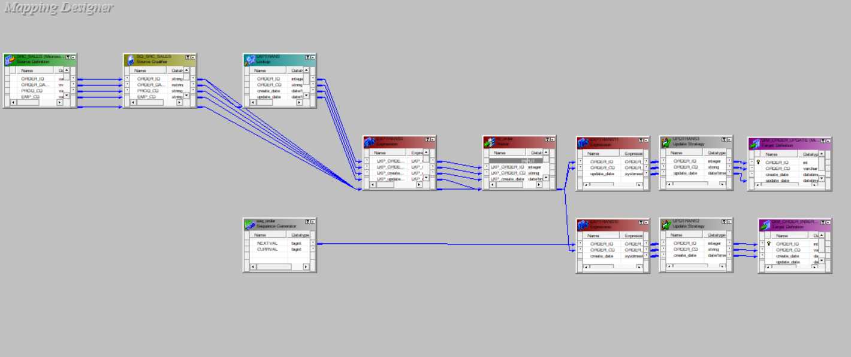 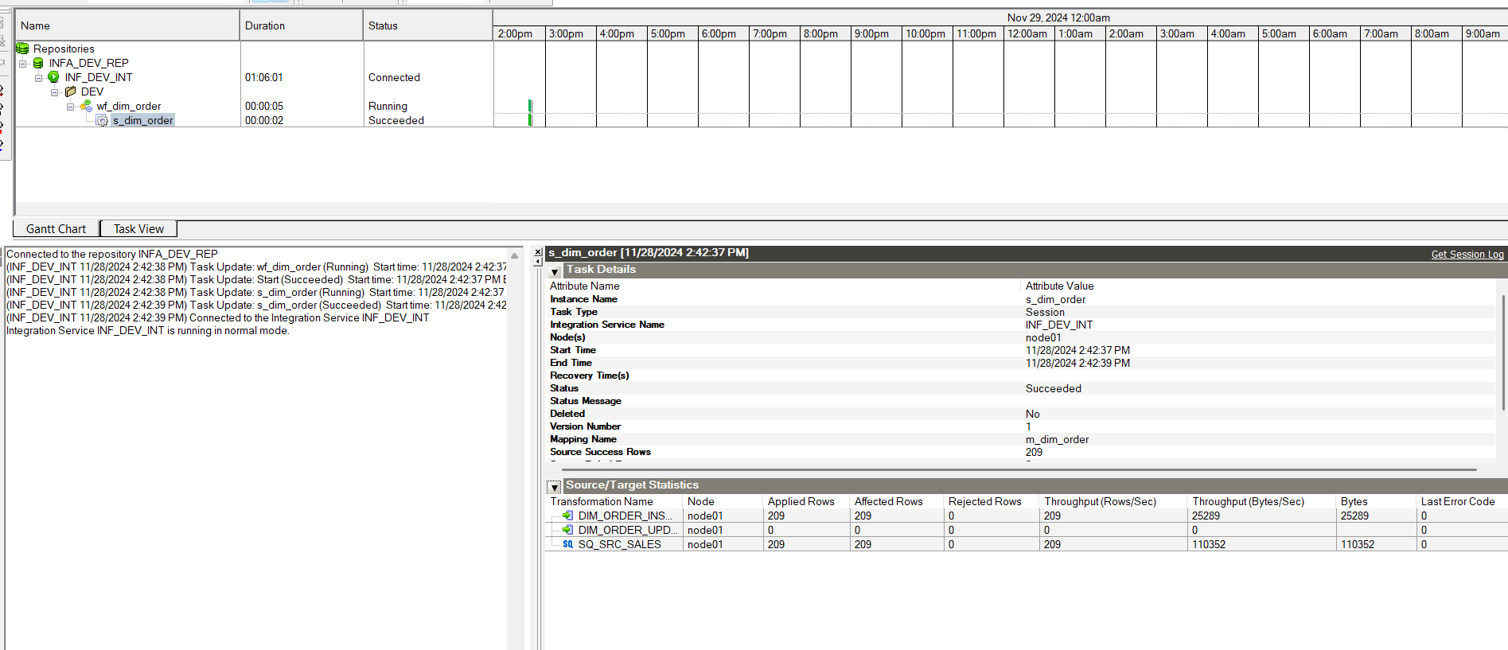

**Product Dimension**

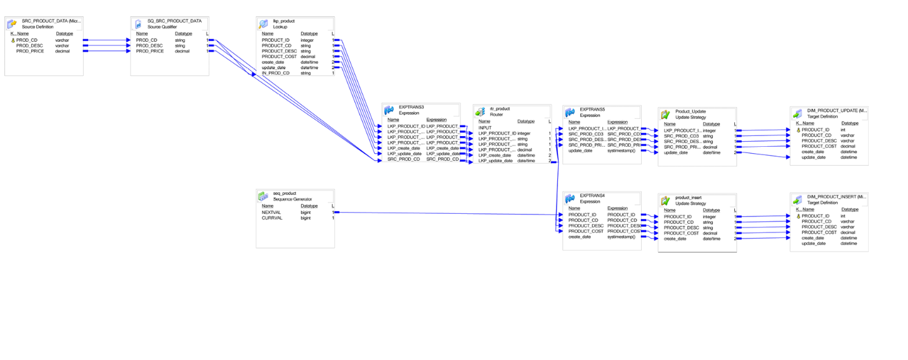

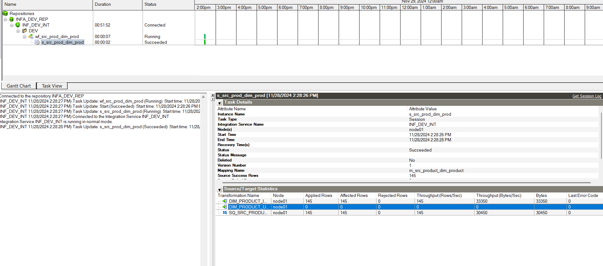

**Region Dimension**

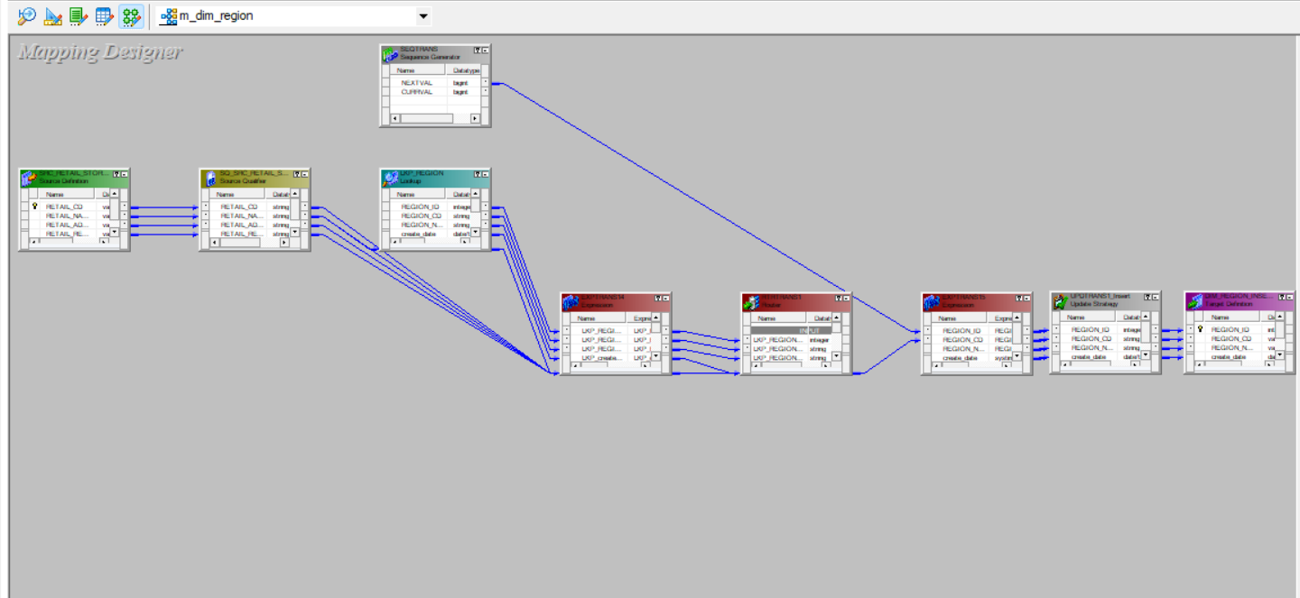 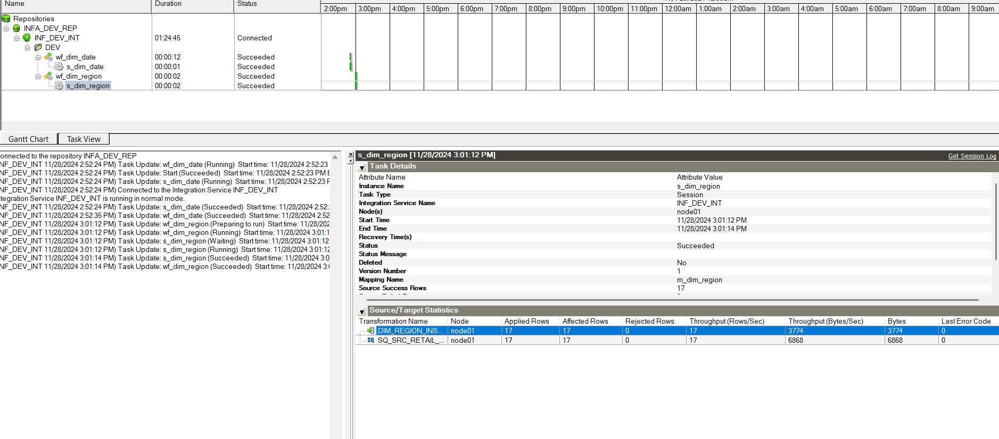

**Retail Dimension**

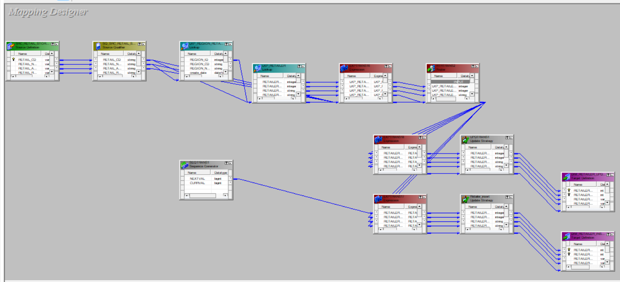

**Fact Sale Dimension**

